19.1.1 Editors - NLA Editor - Header tools and options
Introduction 1
Header Tabs 1
Show Hide elements 1
Only Show Selected 1
Show Hidden 1
Include Missing NLA 1
Filters 2
Filter by Collection 2
Filter by Type 2
Options 2
Sort Data Blocks 2
Auto Snap 2

Introduction

The header contains various menus and tools. This chapter here is about the tools, modes and options elements in the header.

The text menus are covered in an own chapter each.

Header Tabs

The tabs at the very left allows you to switch between the four most important editor types by one click. Dope sheet Editor, Graph Editor, Driver Editor, NLA Editor.

Show Hide elements

Only Show Selected
Display only the data for the selected object in the list of elements. If off it displays all available animation data of the whole scene.

Show Hidden
Include channels from objects / bones that are not visible. This feature just works with Only Selected off.

Include Missing NLA
Include Animation data blocks without NLA data.

Filters
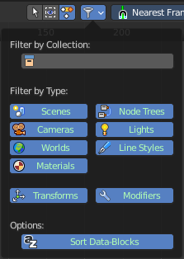
The show hide elements allows you to filter out the general elements. The Filters panel allows you to filter out further elements.

Filter by Collection
Just display the content from the chosen collection in the list of elements.

Filter by Type
In this section you can choose what type of animation data should be displayed. The names should be self explaining.

Options

Sort Data Blocks
Alphabetically sort the data in the list of elements.

Auto Snap

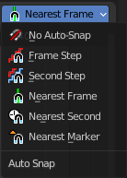
Adjust how the selected keyframe or fcurve point snaps to other elements.

